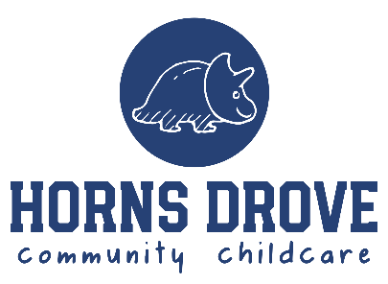
REGISTRATION SUPPLEMENTARY
INFORMATION FORM
Following an offer of a place for your child, the following form should be completed (by someone with parental responsibility) to provide the supplementary information required to complete if you would like to register your child to attend Horns Drove Community Childcare. Please complete the following form, and email to enquiries@hornsdrove.uk

Child’s Details
First name(s)
Last name
Date of birth
Nationality

Child Pick Up
Please confirm below who is authorised* to pick up your child from Horns Drove Community Childcare. If the adult picking up your child is not familiar to staff, they may be asked to provide photographic ID e.g Passport or Driving Licence.
*Please note individual must be 16 or over
Parent/Guardian 1 can pick up child? | Yes | No
Parent/Guardian 1 can pick up child? | Yes | No

Additional Contacts
Please provide details of a minimum of two additional contacts below, including their relationship to the child and whether they are authorised to pick up the child from the setting. If the adult picking up your child is not familiar to staff, they may be asked to provide photographic ID e.g. Passport or Driving Licence.
If you would like to provide details of further contacts, please share these separate to this form.
Additional Contact 1
First name(s)
Last name
Address line 1
Address line 2
Town/city
County
Post Code
Home phone number
Mobile phone number
Work phone number
Email address
Relationship to child
Can pick up child? | Yes | No
Additional Contact 2
First name(s)
Last name
Address line 1
Address line 2
Town/city
County
Post Code
Home phone number
Mobile phone number
Work phone number
Email address
Relationship to child
Can pick up child? | Yes | No

Permissions
Where it is appropriate to do so, we will share relevant information with external agencies. We may also include a profile picture of your child on our internal software platform, FAMLY. Please discuss this with our Childcare Manager if you have concerns with either of these.

Privacy and Safeguarding
- No photographs will be taken in sensitive situations.
- We will obtain explicit consent for any trips off site (outside the boundaries of Rownhams St John School).
- You may withdraw consent at any time by contacting us at enquiries@hornsdrove.uk.
- Images will be held securely and used only for the purposes agreed.

Please can you confirm that you consent to the following, on behalf of your child.
Allergy to penicillin | Yes | No
Administration of liquid paracetamol | Yes | No
Administration of first aid | Yes | No
Application of suncream | Yes | No
In emergency, seek medical attention | Yes | No
Include in photographs of group observations (used on FAMLY APP* and internal displays) | Yes | No
Photographs on social media (Facebook/Instagram) | Yes | No
Photographs on our website (external) | Yes | No
*FAMLY app is a closed group – invitation only

Medical information
Doctors’ information
Name
Address line 1
Address line 2
Town/city
County
Post Code
Phone Number
Details of any Medical Conditions/Medical Plans/Vaccinations
Details of any Allergies
Special Dietary Considerations
Details of any Other Professionals
Include name and contact numbers

Other information
Details of any festivals or special occasions celebrated in your culture

Declaration
I confirm that the information provided in this supplementary information form is true to the best of my knowledge and that I am authorised, as this child’s parent/guardian, to complete the registration.

Full name

